# Крипто про 5

chmod +x ./install_gui.sh

sudo apt-get install whiptail

sudo ./install_gui.sh

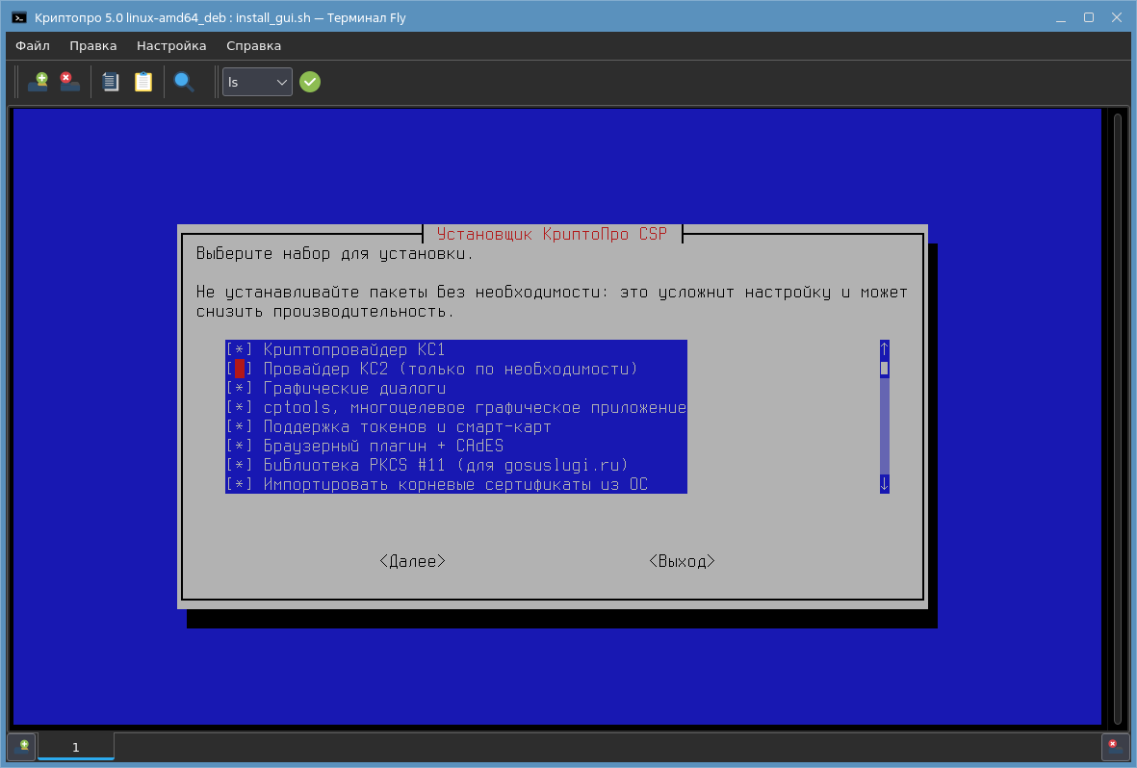

sudo dpkg -i ifd-rutokens_1.0.4_amd64.deb cprocsp-pki-phpcades_2.0.15000-1_all.deb IFCPlugin-x86_64.deb